THE FASTEST WAY TO LEARN THE IRREGULAR VERBS

www.englishirregularverbs.com provides you the best and fastest way to learn one of the most important things in English, the irregular verbs.
This group of verbs are the same in the simple form, simple past and past participle
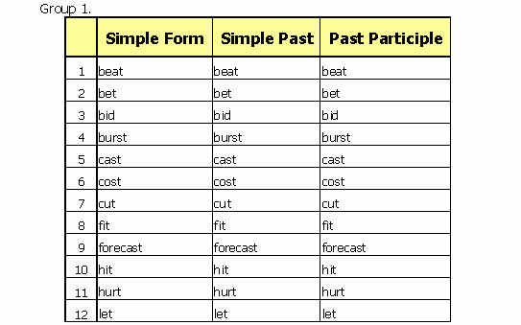
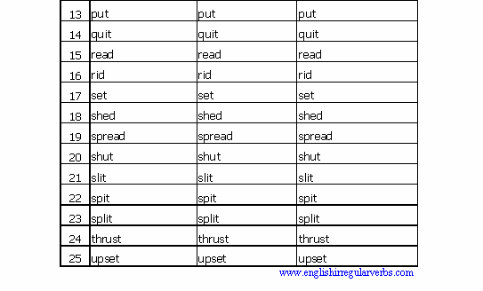
In group 2, the verbs in simple past and past participle end in ought y aught
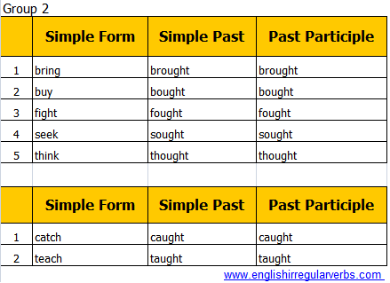
In group 3, the verbs in simple past and past participle end in ept
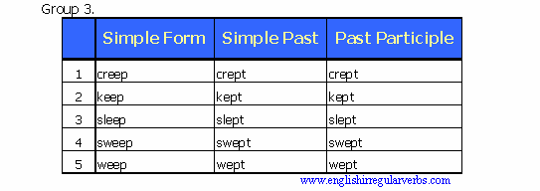
In group 4, withdraw the second vowel from the verbs in simple form and you get the verbs in simple past and past participle
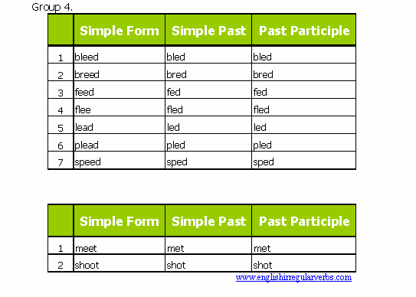
In group 5, substitute the d in the verbs in simple form for a t and you get the verbs in simple past and past participle. In group 6, the verbs in simple past and past participle end in old
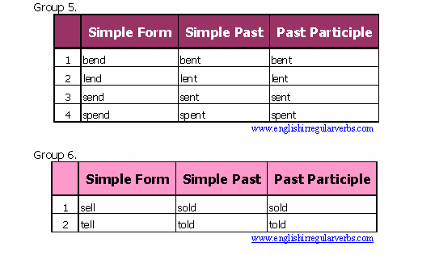
In group 7, substitute the y in the verbs in simple form for id and you get the verbs in simple past and past participle. In group 8, the verbs in simple past and past participle end in lt
`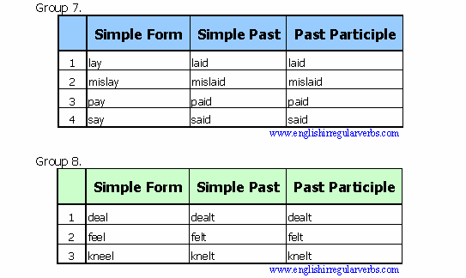
In group 9, the verbs in simple past and past participle end in ung
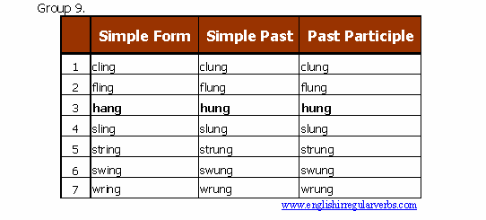
In group 10, the verbs in simple past and past participle end in stood, while in group 11 end in ound
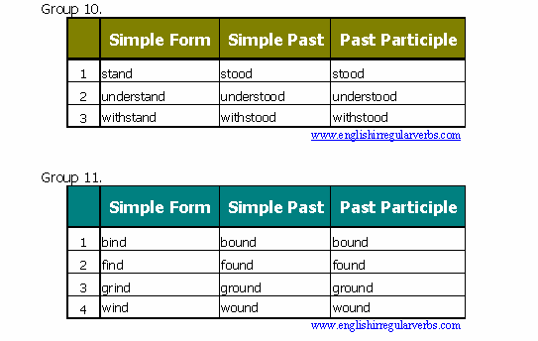
In group 12, verbs in simple form and past participle are the same. Verbs in simple past end in came
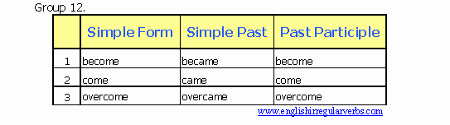
In group 13, substitute the vowel in simple form for an a to get verbs in simple past and for an u to get verbs in past participle
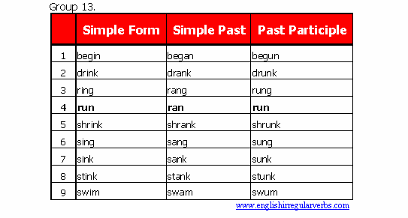
In group 13, verbs in simple past end in ew and verbs in past participle end in own/awn
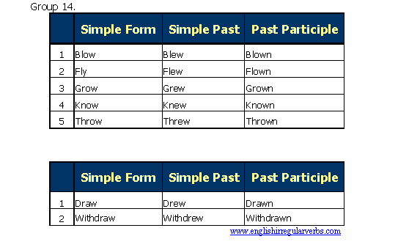
Next, you will find a list of irregular verbs classified in groups which have some similarities that will help you to memorize them easily
