THE OUR FATHER
Our Father, Who art in heaven,
Hallowed be Thy Name.
Thy Kingdom come.
Thy Will be done, on earth as it is in Heaven. Give us this day our daily bread.
And forgive us our trespasses,
as we forgive those who trespass against us.
And lead us not into temptation,
but deliver us from evil.
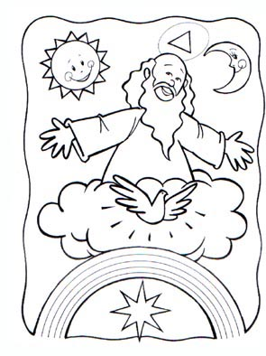
Amen.

THE HAIL MARY
Hail Mary, full of grace.
Our Lord is with you.
Blessed are you among women,
and blessed is the fruit of your womb,
Jesus.
Holy Mary, Mother of God,
pray for us sinners,
now and at the hour of our death.
Amen.

ANGEL OF GOD
Angel of God, my guardian dear, to whom God's love commits me here. Ever this day be at my side, to light and guard, to rule and guide.
Amen.

